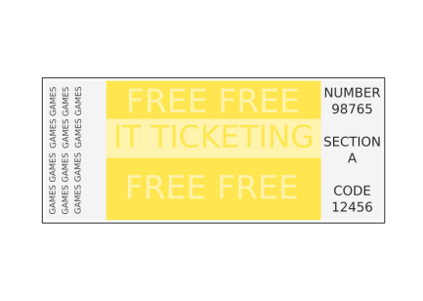1 Eight friends buy one lottery ticket.

They win £1760 and share it equally

**How much does each friend get?**

**A.** £225 **B.** £208  **C.** £220 **D.** £14,080 **E.** £13,600

*Mark the answer on the answer sheet.*

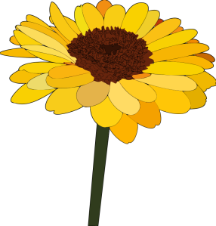2 A sunflower was 0.28 metres high at the beginning of May.

At the end of June it was 0.74 metres high.

**How many centimetres did the plant grow in May and June?**

**A** 56 cm **B** 460 cm **C** 560 cm **D** 46 cm **E** 4.6 cm

*Mark the answer on the answer sheet.*

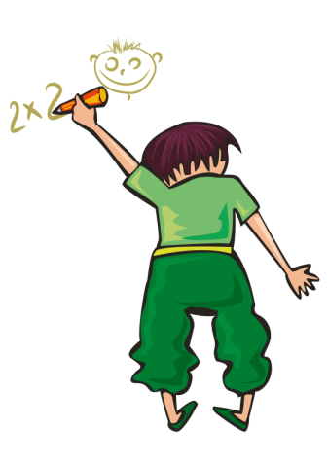

3 **Which one of these number sequences is correct?**

**A** (9 x 3) x (4 ÷ 2) = 24

**B** (9 ÷ 3) x (4 – 2) = 24

**C** (9 – 3) x (4 + 2) = 24

**D** (9 + 3) x (4 x 2) = 24

**E** (9 ÷ 3) x (4 x 2) = 24

*Mark the answer on the answer sheet.*

4 A salesperson in a mobile phone shop is paid £40 per day, plus £30 for each smartphone sold.

*n* is the number of smartphones the salesperson sells on one day.

**Which expression shows how much the salesperson is paid for the day, in pounds?**

**A** 40 + 30n

**B** 70n

**C** 70 + n

**D** 40n + 30n

**E** 30 + 40n

*Mark the answer on the answer sheet.*

5 Emma is having lots of people over for a family meal.

She is going to make a big shepherd’s pie.

She needs 4 kg of potatoes and 3 kg of mince.

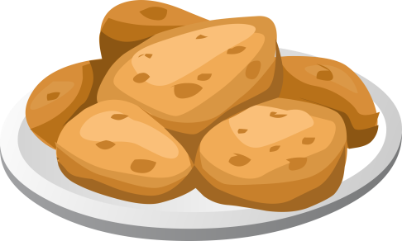**Price per kg**

|  |  |
| --- | --- |
| Potatoes | 57p |
| Carrots | 94p |
| Mince | £1.32 |

**How much will this cost altogether?**

**A** £6.99 **B** £6.24 **C** £9.24 **D** £5.47 **E** £1.89

*Mark the answer on the answer sheet.*

6 Mrs Jones wins £500 in a crossword competition.

She gives £80 to charity and shares out the rest equally between her 8 grandchildren.

**How much does each grandchild receive?**

**A** £62.50 **B** £80 **C** £52.50 **D** £50.50 **E** £10

*Mark the answer on the answer sheet.*

7 15 pupils did a sponsored swim of 10 lengths of the local pool.

The table shows how long it took them to do this.

|  |  |  |  |  |  |
| --- | --- | --- | --- | --- | --- |
| Time in minutes | Less than 10 | 10 to less than 20 | 20 to less than 30 | 30 to less than 40 | 40 to less than 50 |
| Number of pupils | 0 | 7 | 2 | 3 | 3 |

**How many pupils took 20 or more minutes to finish the swim?**

**A** 2 **B** 6 **C** 8 **D** 7 **E** 15

*Mark the answer on the answer sheet.*

8 A group of 10 tourists to London filled in a questionnaire.

They ticked the places they wanted to visit and crossed the places they did not want to visit. The table shows the results.

|  |  |  |  |  |  |  |
| --- | --- | --- | --- | --- | --- | --- |
|  | London  Eye | Tower of London | Trafalgar Square | St Paul’s Cathedral | Madame Tussauds | Buckingham Palace |
| James | √ | √ | √ | *x* | √ | *x* |
| Anne | √ | √ | √ | *x* | *x* | *x* |
| Emma | *x* | *x* | √ | √ | √ | √ |
| Jim | √ | √ | *x* | *x* | √ | *x* |
| Mary | √ | √ | √ | *x* | √ | √ |
| Alice | √ | √ | *x* | √ | *x* | *x* |
| Mark | *x* | √ | *x* | *x* | √ | *x* |
| Peter | √ | *x* | √ | √ | *x* | √ |
| David | √ | √ | *x* | √ | √ | *x* |
| Mary | *x* | √ | √ | *x* | √ | *x* |

**How many people wanted to visit the London Eye and Trafalgar Square but not Madame Tussauds?**

**A** 1 **B** 2 **C** 3 **D** 4 **E** 5

*Mark the answer on the answer sheet.*

**9 At a large cinema there are 48 seats in each row.

There are 27 rows of seats.

**How many seats are there altogether?**

**A** 1200 **B** 1296 **C** 1392 **D** 1396 **E** 1344

*Mark the answer on the answer sheet.*

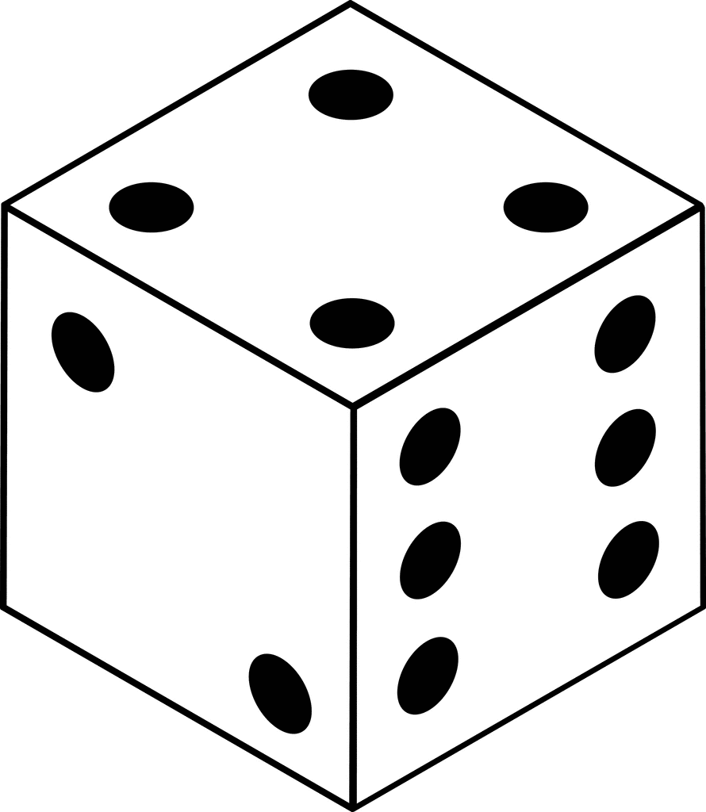10 A dice has 6 sides. The numbers 1 to 6 appear on each side.

Phoebe throws a dice twice.

She gets a 4 on her first throw.

**What is the probability of getting a 4 on the second throw?**

**A $1/{12}$**  **B $1/{36}$** **C $1/{10}$ D $1/4$ E $1/6$**

*Mark the answer on the answer sheet.*

## 11 Mrs Brown goes to buy some new tights. She is 5ft 3 in tall and her dress size is 14.

|  |  |  |
| --- | --- | --- |
| Size | Height | Dress size |
| Extra Small | 4ft 11 in – 5ft 4 in | Under 8 |
| Small | 4ft 11in – 5ft 4 in | 8 - 12 |
| Medium | 4ft 11in – 5 ft 4 in | 14 - 16 |
| Large | 5ft 5 in – 5 ft 9 in | 14 - 16 |
| Extra Large | 5ft 1 in – 5 ft 9 in | 18 - 20 |

**What size tights should she buy?**

**A** Extra Small **B** Small **C** Medium **D** Large **E** Extra Large

*Mark the answer on the answer sheet.*

12 Alice started from a number between 3 and 7 and counted on in steps of 3.

Josh started from the same number as Alice and counted on in steps of 7.

They both reached the number 25.

**What number did they start from?**

**A** 3 **B** 4 **C** 5 **D** 6 **E** 7

*Mark the answer on the answer sheet.*

13 Matthew draws a rectangle on a centimetre square coordinate grid.

Three corners of his rectangle are at points (3, 2), (3, 9), and (8,2).

(3, 9)

(3, 2)

(8, 2)

**What is the perimeter of Matthew’s rectangle?**

**A** 18 **B** 21 **C** 24 **D** 12 **E** 30

*Mark the answer on the answer sheet.*

14 **What is the value of x2 + 4 when x = 6?**

**A** 10 **B** 12 **C** 24 **D** 40 **E** 100

*Mark the answer on the answer sheet.*

15 Add these numbers:

832.73 659.48 1001.53

**Which of these is closest to the total?**

**A** 2493 **B** 2490 **C** 2492 **D** 2494 **E** 2495

*Mark the answer on the answer sheet.*

16 Some 2D shapes are joined together to make a 3D shape.

**Which of these could be used to make a cylinder that is closed at both ends?**

**A** 6 squares

**B** 1 circle and 1 square

**C** 2 circles and 1 rectangle

**D** 1 square and 4 rectangles

**E** 4 squares

*Mark the answer on the answer sheet.*

## 17

|  |  |  |  |  |  |  |  |  |  |  |  |  |
| --- | --- | --- | --- | --- | --- | --- | --- | --- | --- | --- | --- | --- |
|  |  |  |  |  |  |  |  |  |  |  |  |  |
|  | **A** |  |  |  | **B** |  |  |  |  | **C** |  |  |
|  |  |  |  |  |  |  |  |  |  |  |  |  |
|  |  |  |  |  |  |  |  |  |  |  |  |  |
|  |  |  |  |  |  |  |  |  |  |  |  |  |
|  |  |  |  | **D** |  |  |  |  |  |  |  |  |
|  |  |  |  |  |  |  |  |  |  |  |  |  |
|  |  |  |  |  |  |  |  |  |  |  |  |  |
|  | **E** |  |  |  |  |  |  |  |  |  |  |  |
|  |  |  |  |  |  |  |  |  |  |  |  |  |
|  |  |  |  |  |  |  |  |  |  |  |  |  |

**Which shape has a different fraction shaded?**

**A** A **B** B **C** C **D** D **E** E

*Mark the answer on the answer sheet.*

18 A jar had 10 blue marbles, 8 red marbles and 6 green marbles.

The jar tipped over and 6 of the marbles fell out.

After it tipped over, the probability of selecting a blue marble was $1/3$.

**How many blue marbles spilled out?**

**A** 6 **B** 4 **C** 3 **D** 1 **E** 5

*Mark the answer on the answer sheet.*

19 **Which of these shapes has exactly 8 edges?**

**A** triangular pyramid

**B** cuboid

**C** triangular prism

**D** square pyramid

**E** cube

*Mark the answer on the answer sheet.*

20 900 students attend Milford School.

30% walk to school.

**How many walk?**

**A** 400 **B** 360 **C** 320 **D** 270 **E** 290

*Mark the answer on the answer sheet.*

|  |  |  |  |  |  |  |  |  |  |  |
| --- | --- | --- | --- | --- | --- | --- | --- | --- | --- | --- |
|  |  |  |  | 6 |  |  |  |  |  |  |
|  |  |  |  | 5 |  |  |  |  |  |  |
|  |  |  |  | 4 |  |  |  | Y |  |  |
|  |  |  |  | 3 |  |  |  |  | Z |  |
|  |  |  |  | 2 |  |  |  |  |  |  |
|  |  |  |  | 1 |  |  | X |  |  |  |
|  |  |  |  | 0 |  |  |  |  |  |  |
| -4 | -3 | -2 | -1 | -1 | 11 | 2 | 3 | 4 | 5 |  |
|  |  |  |  | -2 |  |  |  |  |  |  |
|  |  |  |  |  |  |  |  |  |  |  |

## 21

The triangle XYZ is rotated 90o clockwise about the black dot

**What will be the coordinates of X?**

**A** (1, 1) **B** (0, 2) **C** (-1, -1) **D** (0, 0) **E** (2, 0)

*Mark the answer on the answer sheet.*

22 A road is 2.20 km long.

Roadworks are slowing the traffic down on half of its length.

**How far is half its length in metres?**

**A** 220 m **B** 2020 **C** 1100 m **D** 440 m **E** 80 m

*Mark the answer on the answer sheet.*

23 36 x 38 = 1368

**Which one of these is not correct?**

**A** 1368 ÷ 38 = 4 x 9

**B** 4 x 38 x 9 = 1368

**C** 2 x 36 = 1368 ÷ 19

**D** 4 x 9 x 19 = 1368 ÷ 3

**E** 1368 ÷ 4 = 38 x 9

*Mark the answer on the answer sheet.*

## 24

Front left edge

A cuboid is resting on a table.

It is rotated anti-clockwise about its front left edge through 1 right angle.

**Which shows the correct final position?**

**A**

**D**

**B**

**C**

**E**

**A** A **B** B **C** C **D** D **E** E

*Mark the answer on the answer sheet.*

25 There are 15 chocolates in a box.

3 are dark chocolate.

**What percentage are dark chocolate?**

**A** 3% **B** 20% **C** 15% **D** 5% **E** 25%

*Mark the answer on the answer sheet.*

## 26

|  |  |  |  |  |  |  |  |  |  |  |
| --- | --- | --- | --- | --- | --- | --- | --- | --- | --- | --- |
|  |  |  |  |  |  |  |  |  |  |  |
|  |  |  |  |  |  |  |  |  |  |  |
|  |  |  |  |  |  |  |  |  |  |  |
| **P** |  |  |  |  |  |  |  |  |  |  |
| 11  10  9  8  7  6  5  4  3  2  1 |  |  |  |  |  |  |  |  |  |  |
|  |  |  |  |  |  |  |  |  |  |  |
|  |  |  |  |  |  |  |  |  |  |  |
|  |  |  |  |  | **Q** |  |  |  |  |  |
|  |  |  |  |  |  |  |  |  |  |  |
|  |  |  |  |  |  |  |  |  |  |  |

0 1 2 3 4 5 6 7 8 9 10 11

**Which set of instructions will transform triangle P to Q?**

**A** Rotate 90o clockwise about (3, 5) - Move right 1 down 1

**B** Rotate 180o about (3, 5) - Move down 1 right 3

**C** Rotate 90o anti-clockwise about (3, 5) - Move right 2 down 1

**D**Rotate 90o clockwise about (1, 5) - Move right 4 down 1

**E** Rotate 90o clockwise about (1, 5) - Move down 2 right 3

*Mark the answer on the answer sheet.*

27 A bird weighs 0.18 kg.

When the bird sits on an elephant the total weight of the bird and the elephant is 4201kg.

**How much does the elephant weigh?**

**A** 4219 kg

**B** 4201.18 kg

**C** 4183 kg

**D**  4200.82 kg

**E** 4199.2 kg

*Mark the answer on the answer sheet.*

## 28 **Pattern:**

**1 2 3**

Matchsticks are arranged in patterns 1, 2 and 3.

**What is the formula for the number of matchsticks in the *n*th pattern?**

**A** 3*n* + 4

**B** 3 + *n* + 1

**C** 3*n* + 1

**D** 4 + 3*n*

**E** 4*n*

*Mark the answer on the answer sheet.*

29 **What is the difference in area between a square with a side length of 6 centimetres, and 6 square centimetres?**

**A** 6 cm2 **B** 24 cm2 **C** 0 cm2 **D** 20 cm2 **E** 30 cm2

*Mark the answer on the answer sheet.*

30 Amy and Sue are counting back in 39s from 200.

They take turns.

Amy takes away the first 39, Sue takes away the second 39, and so on.

**What is Amy’s first negative answer?**

**A** -39 **B** -73 **C** -44 **D** -34 **E** -53

*Mark the answer on the answer sheet.*

Maths challenge – Answer recording sheet

|  |  |  |  |  |  |  |  |  |  |  |  |  |  |
| --- | --- | --- | --- | --- | --- | --- | --- | --- | --- | --- | --- | --- | --- |
| **1** | |  | **2** | |  | **3** | |  | **4** | |  | **5** | |
| A |  |  | A |  |  | A |  |  | A |  |  | A |  |
| B |  |  | B |  |  | B |  |  | B |  |  | B |  |
| C |  |  | C |  |  | C |  |  | C |  |  | C |  |
| D |  |  | D |  |  | D |  |  | D |  |  | D |  |
| E |  |  | E |  |  | E |  |  | E |  |  | E |  |

|  |  |  |  |  |  |  |  |  |  |  |  |  |  |
| --- | --- | --- | --- | --- | --- | --- | --- | --- | --- | --- | --- | --- | --- |
| **6** | |  | **7** | |  | **8** | |  | **9** | |  | **10** | |
| A |  |  | A |  |  | A |  |  | A |  |  | A |  |
| B |  |  | B |  |  | B |  |  | B |  |  | B |  |
| C |  |  | C |  |  | C |  |  | C |  |  | C |  |
| D |  |  | D |  |  | D |  |  | D |  |  | D |  |
| E |  |  | E |  |  | E |  |  | E |  |  | E |  |

|  |  |  |  |  |  |  |  |  |  |  |  |  |  |
| --- | --- | --- | --- | --- | --- | --- | --- | --- | --- | --- | --- | --- | --- |
| **11** | |  | **12** | |  | **13** | |  | **14** | |  | **15** | |
| A |  |  | A |  |  | A |  |  | A |  |  | A |  |
| B |  |  | B |  |  | B |  |  | B |  |  | B |  |
| C |  |  | C |  |  | C |  |  | C |  |  | C |  |
| D |  |  | D |  |  | D |  |  | D |  |  | D |  |
| E |  |  | E |  |  | E |  |  | E |  |  | E |  |

|  |  |  |  |  |  |  |  |  |  |  |  |  |  |
| --- | --- | --- | --- | --- | --- | --- | --- | --- | --- | --- | --- | --- | --- |
| **16** | |  | **17** | |  | **18** | |  | **19** | |  | **20** | |
| A |  |  | A |  |  | A |  |  | A |  |  | A |  |
| B |  |  | B |  |  | B |  |  | B |  |  | B |  |
| C |  |  | C |  |  | C |  |  | C |  |  | C |  |
| D |  |  | D |  |  | D |  |  | D |  |  | D |  |
| E |  |  | E |  |  | E |  |  | E |  |  | E |  |

|  |  |  |  |  |  |  |  |  |  |  |  |  |  |
| --- | --- | --- | --- | --- | --- | --- | --- | --- | --- | --- | --- | --- | --- |
| **21** | |  | **22** | |  | **23** | |  | **24** | |  | **25** | |
| A |  |  | A |  |  | A |  |  | A |  |  | A |  |
| B |  |  | B |  |  | B |  |  | B |  |  | B |  |
| C |  |  | C |  |  | C |  |  | C |  |  | C |  |
| D |  |  | D |  |  | D |  |  | D |  |  | D |  |
| E |  |  | E |  |  | E |  |  | E |  |  | E |  |

|  |  |  |  |  |  |  |  |  |  |  |  |  |  |
| --- | --- | --- | --- | --- | --- | --- | --- | --- | --- | --- | --- | --- | --- |
| **26** | |  | **27** | |  | **28** | |  | **29** | |  | **30** | |
| A |  |  | A |  |  | A |  |  | A |  |  | A |  |
| B |  |  | B |  |  | B |  |  | B |  |  | B |  |
| C |  |  | C |  |  | C |  |  | C |  |  | C |  |
| D |  |  | D |  |  | D |  |  | D |  |  | D |  |
| E |  |  | E |  |  | E |  |  | E |  |  | E |  |

Answers

|  |  |  |  |  |  |  |  |
| --- | --- | --- | --- | --- | --- | --- | --- |
| **1.** | C |  | **11.** | C |  | **21.** | E |
| **2.** | D |  | **12.** | B |  | **22.** | C |
| **3.** | E |  | **13.** | C |  | **23.** | D |
| **4.** | A |  | **14.** | D |  | **24.** | C |
| **5.** | B |  | **15.** | D |  | **25.** | B |
| **6.** | C |  | **16.** | C |  | **26.** | D |
| **7.** | C |  | **17.** | D |  | **27.** | D |
| **8.** | B |  | **18.** | B |  | **28.** | C |
| **9.** | B |  | **19.** | D |  | **29.** | E |
| **10.** | E |  | **20.** | D |  | **30.** | B |